## Scoring 1.02 – when things go wrong

* BCS still running from previous session? Kill Invisible Session (never happens after a reboot)
* Hand Records Not Visible to Players
* Restarting a Session – late arrival? Miscounted tables? Phantom?
* Lots of TBA’s in Results/Scores screens - Re-read Names/Scores
* Correcting Names, substitutions in Teams and Swiss Pairs
* Correcting Scores (Score Adjustments to be covered in afternoon)
* Handicaps Missing
* Results not Posting to Website – ShipResults
* Simulations
* Import Log File
* Wrong file chosen – previous one overwritten
* Recover files from Dropbox Activity
* .bws incomplete? - re-send results from TTU’s

To end a session prematurely (to cancel the last round or two because it's taking longer than you thought - but often because you wish to start again with a new movement) you should go into Adjustments and End This Session Before All Rounds Are Played (follow the instructions). At least with Bridgemates this has the effect of instructing the table-top units that it's all over rover - bring on the next one. To be absolutely certain that you've nailed the beast with a stake through its heart, exit Compass then go to :c/CompassV6/2025 and delete the INP .. then into the Bridgemate subfolder and delete the BWS. It is seldom necessary to reboot the computer.

### Specific Requests

How and when to apply ASM and FBM

Score corrections after cards get switched (FBM’s)

Piggybacks _x mechanism

Check CM is showing the expected movement .. esp when there are 2 sections or a piggyback. Untick Read Names to stop it jumping around while you scroll

### Scoring 1.02 – Healthy Practices

MAJOR TIP #1 .. check dropbox synched before turning off

MAJOR TIP #2 .. reboot the scoring computer at least once a week and *always* before starting to score a tournament

MAJOR TIP #3 .. Exit Compass to write a backup for support to read when you spot a problem

MAJOR TIP #4 .. hold off starting the session until all boards are laid out on tables and you have thoroughly re-read the instructions. Even then the TTU’s may throw up some wobberlies

Tick CISU > Club Options (1) to have SAM open by default

Good to have Auto-Shutdown ticked in CISU > Bridgemate Options (3). Untick Auto-Start

How to truncate a session and shut down properly …

24 Webb vs 24 T&B – with a phantom Webb has a 3-board sit-out vs 2-board for T&B

BCS green when first going in .. Invisible Session or previous one still running

XG Handicapping

Subs in Teams

Posting to Milan website process

ShipResults – autosend? SR Stuff .. master computer

Power cord fell out of server and battery drained – re-send data from Bridgemates

Finish play – results screen shows none or not all boards have been played .. 22mond example

Manually entered handicaps

### Scoring 1.03 – Scores Adjustments

Difference between DNP and Passed-In (Neuberg Adjustment)

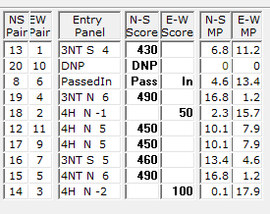

Artificial score eg 60/40

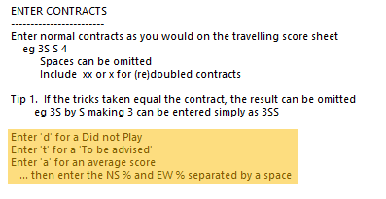

Adjust overall score arising from damage or infraction – penalty

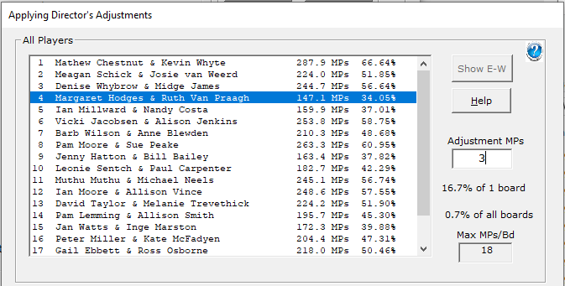

Arrow-switch matchpointing (ASM)

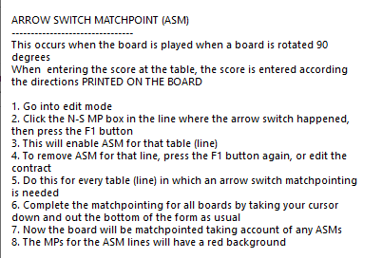

Fouled board matchpointing (FBM)

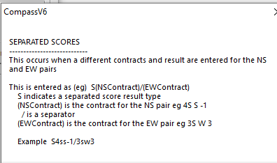

Single Weighted Score

